DCC-GARCH correlation: GBPUSD and NZDUSD
Method 09 / GARCH(1,1) + Engle DCC / Alpari D1 full available history

Study setup
Logical pair: GBPUSD , NZDUSD
Broker symbols: GBPUSD_i , NZDUSD_i
Snapshot: 2026-11-03_majors_alpari_D1
Timeframe: D1
Matched return window: 1999-01-05 to 2026-11-02 (UTC bar dates)
Matched return count n: 7203
Dropped unfinished last bar dated 2026-11-03 UTC after a tick-volume check against the prior complete day.
GBPUSD GARCH(1,1): mu=0.000019, omega=0.004049, alpha=0.055534, beta=0.931977
NZDUSD GARCH(1,1): mu=0.000000, omega=0.004924, alpha=0.040666, beta=0.950360
DCC: a=0.021226, b=0.977008, a+b=0.998234
Burn-in ignored in path summaries and chart: first 60 updates
Complete matched rows (Excel): GBPUSD-NZDUSD_DCC_D1.xlsx
Complete matched rows (HTML table): GBPUSD-NZDUSD_DCC_D1_data.html

Method carried forward
DCC-GARCH first fits a constant-mean GARCH(1,1) on each matched daily log return of close, ln(close_t / close_t-1), then updates Engle (2002) dynamic conditional correlation on the standardised shocks z = residual / conditional sigma. Quotes are not inverted. Correlation targeting sets Q_bar to the sample correlation of z; a and b are estimated by maximising the bivariate Gaussian DCC likelihood with a >= 0, b >= 0, and a + b < 1. Path summaries ignore the first 60 updates. The headline is rho on the last day. Same-sample Pearson r on log returns is a side check only. A high |rho| does not prove cause, lead-lag, or a trading signal.

Results
Latest DCC rho: 0.667040
Post-burn-in path (n=7143): mean=0.502909, median=0.507919, min=0.057612, max=0.806951, std=0.172573
Share of post-burn-in days with |rho| >= 0.4: 71.10%; |rho| >= 0.7: 15.01%
Same-sample Pearson r: 0.530079
Latest rho minus r: 0.136961

Conclusion
Over 7203 matched daily log-return rows for GBPUSD and NZDUSD (broker quote directions unchanged), latest DCC rho is 0.6670 (positive, moderate conditional linear link in this sample) with fitted a=0.0212, b=0.9770 (a+b=0.9982). After a 60-day burn-in, path mean is 0.5029 and std is 0.1726. Same-sample Pearson r is 0.5301 (latest rho minus r = 0.1370). This does not establish cause, lead-lag, or a lasting trading rule.

Charts
Daily closes

Daily log returns
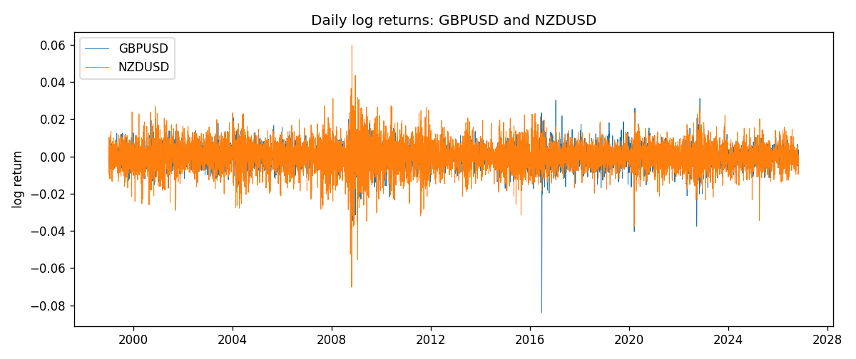
DCC rho path with Pearson r reference
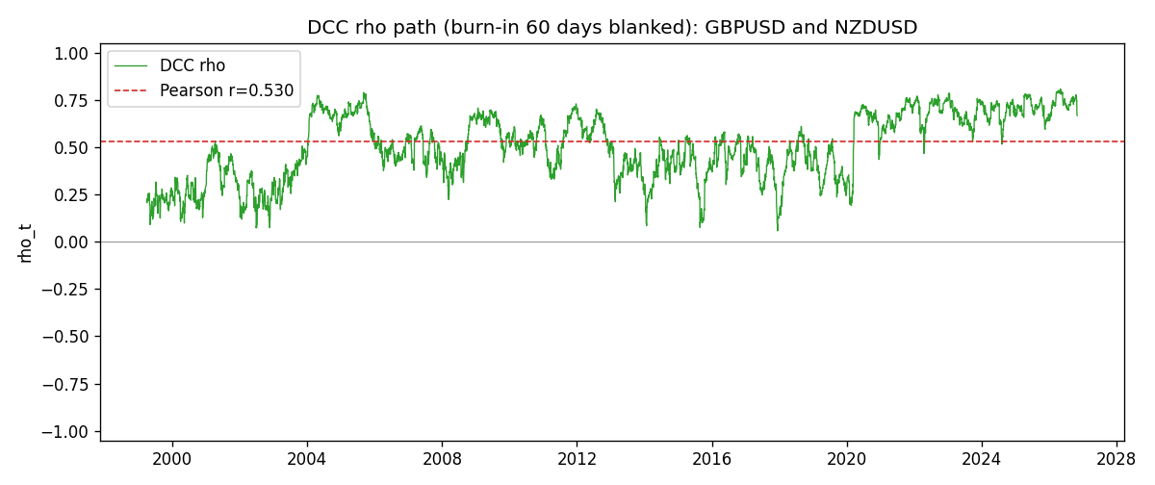

Data report
Every matched row that entered the DCC recursion is stored in the sibling Excel workbook named GBPUSD-NZDUSD_DCC_D1.xlsx. Embedding all rows as a Word table is impractical at this length; the Word file holds the column list, column summaries, and the first and last 15 matched rows.
Columns: time, GBPUSD_open, NZDUSD_open, GBPUSD_high, NZDUSD_high, GBPUSD_low, NZDUSD_low, GBPUSD_close, NZDUSD_close, GBPUSD_tick_volume, NZDUSD_tick_volume, GBPUSD_spread, NZDUSD_spread, GBPUSD_real_volume, NZDUSD_real_volume, GBPUSD_log_return, NZDUSD_log_return, GBPUSD_sigma, NZDUSD_sigma, GBPUSD_z, NZDUSD_z, q11, q22, q12, rho_t
Column summaries (matched calculation rows)
column | count | mean | std | min | 25% | 50% | 75% | max
GBPUSD_open | 7203 | 1.5160351 | 0.21820856 | 1.06854 | 1.32502 | 1.51126 | 1.63163 | 2.1066
NZDUSD_open | 7203 | 0.65617721 | 0.10827592 | 0.3913 | 0.59107 | 0.6683 | 0.72469 | 0.88218
GBPUSD_high | 7203 | 1.5223294 | 0.21877071 | 1.08366 | 1.3298 | 1.51797 | 1.63833 | 2.1161
NZDUSD_high | 7203 | 0.66009189 | 0.10877133 | 0.3961 | 0.594565 | 0.67188 | 0.729235 | 0.88421
GBPUSD_low | 7203 | 1.5097156 | 0.21743942 | 1.03518 | 1.319525 | 1.50315 | 1.62431 | 2.0983
NZDUSD_low | 7203 | 0.65248767 | 0.1078698 | 0.3897 | 0.587935 | 0.66402 | 0.72082 | 0.87988
GBPUSD_close | 7203 | 1.5161019 | 0.21816437 | 1.06879 | 1.32515 | 1.51122 | 1.63196 | 2.1065
NZDUSD_close | 7203 | 0.65624807 | 0.10827144 | 0.3907 | 0.591395 | 0.6683 | 0.724915 | 0.8822
GBPUSD_tick_volume | 7203 | 94800.961 | 153533.35 | 62 | 9991 | 52873 | 91772.5 | 1273370
NZDUSD_tick_volume | 7203 | 68552.383 | 123030.52 | 16 | 5500.5 | 33815 | 58467.5 | 1127682
GBPUSD_spread | 7203 | 26.976121 | 19.194852 | 0 | 11 | 20 | 50 | 50
NZDUSD_spread | 7203 | 30.373178 | 25.676979 | 0 | 9 | 17 | 50 | 80
GBPUSD_real_volume | 7203 | 3.5551025e+09 | 8.4426509e+10 | 0 | 0 | 0 | 0 | 2.4038164e+12
NZDUSD_real_volume | 7203 | 1.6657093e+10 | 8.4881524e+10 | 0 | 0 | 0 | 0 | 2.705649e+12
GBPUSD_log_return | 7203 | -2.372e-05 | 0.00564203 | -0.08388241 | -0.00312422 | 3.221e-05 | 0.0031735 | 0.03112653
NZDUSD_log_return | 7203 | 5.29e-06 | 0.00764545 | -0.07027433 | -0.00426254 | 0.00021291 | 0.00457891 | 0.05966839
GBPUSD_sigma | 7203 | 0.00539261 | 0.00169297 | 0.00300535 | 0.00447645 | 0.00503236 | 0.00577524 | 0.02201778
NZDUSD_sigma | 7203 | 0.00728856 | 0.00216942 | 0.00438969 | 0.00595858 | 0.00670876 | 0.00804031 | 0.02523043
GBPUSD_z | 7203 | -0.00685012 | 1.000022 | -10.30555 | -0.6000551 | 0.00290134 | 0.60658892 | 4.9462534
NZDUSD_z | 7203 | -0.00236753 | 1.0000747 | -5.6200599 | -0.63176558 | 0.03249755 | 0.64626906 | 4.2140658
q11 | 7203 | 1.0015446 | 0.20073397 | 0.53956238 | 0.89822454 | 0.98195088 | 1.0695407 | 3.589167
q22 | 7203 | 1.0016518 | 0.17439174 | 0.63867439 | 0.88246244 | 0.97264626 | 1.0844506 | 2.1973836
q12 | 7203 | 0.50219753 | 0.20108872 | 0.05305294 | 0.35788327 | 0.5033087 | 0.63234394 | 1.3077911
rho_t | 7203 | 0.50060876 | 0.17388969 | 0.05761194 | 0.37460701 | 0.50508974 | 0.6606996 | 0.80695084
First 15 matched rows (selected columns)
time | GBPUSD_log_return | NZDUSD_log_return | GBPUSD_sigma | NZDUSD_sigma | GBPUSD_z | NZDUSD_z | q11 | q22 | q12 | rho_t
1999-01-05 | -0.0028966287 | -0.0018597736 | 0.0040780725 | 0.0058823963 | -0.71496668 | -0.31623 | 1 | 1 | 0.50208529 | 0.50208529
1999-01-06 | -0.00060452184 | 0.0020455609 | 0.0040467846 | 0.0057894761 | -0.15409249 | 0.35325207 | 0.98962406 | 0.98089627 | 0.49622699 | 0.50365566
1999-01-07 | -0.002118709 | 0.0062963171 | 0.0039609384 | 0.0057023408 | -0.53971206 | 1.1040905 | 0.96914023 | 0.96275788 | 0.48454879 | 0.5016325
1999-01-08 | -0.0058954193 | -0.00055396548 | 0.0039090359 | 0.0057451636 | -1.5130269 | -0.096495426 | 0.95480638 | 0.96826307 | 0.46164591 | 0.48012536
1999-01-11 | -0.0056851331 | 0.010290425 | 0.0040729263 | 0.0056456481 | -1.400514 | 1.8226444 | 0.98321161 | 0.94796402 | 0.45501728 | 0.47131197
1999-01-12 | 0.0022657001 | -0.0053157489 | 0.0042038347 | 0.0059236357 | 0.53442702 | -0.89744976 | 1.0040055 | 0.99844881 | 0.39125867 | 0.39078063
1999-01-13 | 0.0091330396 | -0.0099742238 | 0.0041419032 | 0.0059151764 | 2.2004334 | -1.6862794 | 0.98874954 | 0.99435416 | 0.3729687 | 0.37614794
1999-01-14 | 0.0019376331 | -0.00018564931 | 0.0045832621 | 0.0061474272 | 0.41860486 | -0.03026727 | 1.0705581 | 1.0336157 | 0.28651836 | 0.27237535
1999-01-15 | -0.0017558204 | -0.00074294208 | 0.0044929667 | 0.0060339649 | -0.39503468 | -0.12319571 | 1.0514289 | 1.0116358 | 0.28054827 | 0.27202295
1999-01-18 | 0.0012112405 | -0.0018597736 | 0.004403803 | 0.0059258987 | 0.27071674 | -0.31390853 | 1.0323325 | 0.99046404 | 0.2760174 | 0.27296522
1999-01-19 | 0.0018745281 | 0.0018597736 | 0.0043079183 | 0.0058314855 | 0.43071172 | 0.31884794 | 1.0119183 | 0.97154851 | 0.26875386 | 0.27105021
1999-01-20 | -0.0049053846 | 0.0040793678 | 0.0042298842 | 0.005740309 | -1.1642025 | 0.71058044 | 0.99435566 | 0.95313422 | 0.26637621 | 0.2736198
1999-01-21 | 0.0031518998 | 0.0040627941 | 0.0042926125 | 0.0056995133 | 0.72982188 | 0.71275869 | 1.0020286 | 0.94370309 | 0.24357842 | 0.25048462
1999-01-22 | 0.0024781662 | -0.012051689 | 0.0042571232 | 0.0056599855 | 0.57764571 | -2.1293528 | 0.9920616 | 0.93455461 | 0.24990624 | 0.25954068
1999-01-25 | 0.0012066366 | -0.0035504102 | 0.0041989389 | 0.0060699664 | 0.28282845 | -0.58498292 | 0.97810043 | 1.0110765 | 0.21893816 | 0.22015966
Last 15 matched rows (selected columns)
time | GBPUSD_log_return | NZDUSD_log_return | GBPUSD_sigma | NZDUSD_sigma | GBPUSD_z | NZDUSD_z | q11 | q22 | q12 | rho_t
2026-10-13 | 0.0036434319 | 0.0047326165 | 0.0036717038 | 0.0049253242 | 0.98710975 | 0.96078954 | 0.7439062 | 0.7300752 | 0.55901218 | 0.75853981
2026-10-14 | -0.0049164679 | -0.0037306483 | 0.003701191 | 0.0049454708 | -1.3334965 | -0.75444076 | 0.74925061 | 0.73464935 | 0.56717707 | 0.76447813
2026-10-15 | 0.0065976411 | 0.0047634855 | 0.00381113 | 0.0049297174 | 1.7261505 | 0.96619512 | 0.77153449 | 0.73160555 | 0.57637771 | 0.76716894
2026-10-16 | 0.0037592051 | 0.0057501001 | 0.0040429008 | 0.004950833 | 0.92511492 | 1.1613568 | 0.81880705 | 0.73636562 | 0.59941347 | 0.77194962
2026-10-19 | -0.0017500314 | 0.0018917133 | 0.0040515441 | 0.0050130645 | -0.43664554 | 0.37727357 | 0.81991299 | 0.74982979 | 0.60932364 | 0.77711053
2026-10-20 | 0.0055923442 | 0.0037199341 | 0.0039846161 | 0.0049518874 | 1.3987011 | 0.75113129 | 0.80687416 | 0.73737657 | 0.59270382 | 0.76840496
2026-10-21 | 0.0012476328 | 0.0030923331 | 0.0041142536 | 0.0049354808 | 0.29861445 | 0.62646716 | 0.83161469 | 0.7341643 | 0.60226349 | 0.77077714
2026-10-22 | 0.00022396082 | -0.0033035227 | 0.0040329176 | 0.0049021385 | 0.050807771 | -0.67397916 | 0.81615257 | 0.72738053 | 0.5932736 | 0.76999607
2026-10-23 | -0.0021146949 | 0.0030929853 | 0.0039452948 | 0.0048758981 | -0.54083467 | 0.63425623 | 0.79920799 | 0.72206424 | 0.57979267 | 0.76322905
2026-10-26 | -0.0024340661 | -0.0028993932 | 0.0038941418 | 0.0048451581 | -0.62995226 | -0.59849641 | 0.78880696 | 0.71576712 | 0.56006732 | 0.74536499
2026-10-27 | -0.0023648393 | -0.00026399852 | 0.0038564181 | 0.0048108827 | -0.61816342 | -0.054961858 | 0.78085979 | 0.70867905 | 0.5560796 | 0.74752485
2026-10-28 | 0.0015771808 | -0.0097283914 | 0.003818491 | 0.0047424617 | 0.40804693 | -2.0514257 | 0.77278302 | 0.69421482 | 0.54490187 | 0.74394799
2026-10-29 | 0.0035881935 | 0.00062190714 | 0.003758831 | 0.0050710884 | 0.94953358 | 0.12255567 | 0.76031504 | 0.7693471 | 0.51549182 | 0.6740061
2026-10-30 | 0.0013450605 | 0.00019537668 | 0.0037789035 | 0.0049947482 | 0.35089628 | 0.039033029 | 0.76373749 | 0.75374268 | 0.50699625 | 0.66822256
2026-11-02 | 0.0010971256 | -0.0025962955 | 0.0037163597 | 0.0049196611 | 0.29008718 | -0.52782336 | 0.7505568 | 0.73821057 | 0.4965166 | 0.66703997

